Disconnected Architecture in ADO.NET

The architecture of ADO.net in which data retrieved from database can be accessed even when connection to database was closed is called as disconnected architecture. Disconnected architecture of ADO.net was built on classes: **connection**, **dataadapter**, **commandbuilder** and **dataset** and **dataview**.  
  
  
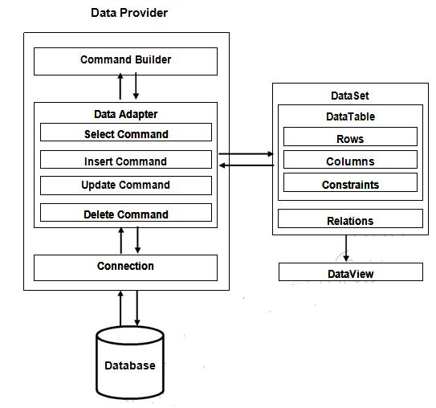  
  
 **Connection :**Connection object is used to establish a connection to database and connection itself it will not transfer any data.

**DataAdapter:**DataAdapter is used to transfer the data between database and dataset. It hascommands like select, insert, update and delete. Select command is used to retrieve data from database and insert, update and delete commands are used to send changes to the data in dataset to database. It needs a connection to transfer the data.

**CommandBuilder:**by default dataadapter contains only the select command and it doesn’t contain insert, update and delete commands. To create insert, update and delete commands for the dataadapter, commandbuilder is used. It is used only to create these commands for the dataadapter and has no other purpose.

**DataSet:**Dataset is used to store the data retrieved from database by dataadapter and make itavailable for .net application.

To fill data in to dataset **fill()** method of dataadapter is used and has the following syntax.

**Da.Fill(Ds,”TableName”);**

When fill method was called, dataadapter will open a connection to database, executes select command, stores the data retrieved by select command in to dataset and immediately closes the connection.

As connection to database was closed, any changes to the data in dataset will not be directly sent to the database and will be made only in the dataset. To send changes made to data in dataset to the database, **Update()** method of the dataadapter is used that has the following syntax.

**Da.Update(Ds,”Tablename”);**

When Update method was called, dataadapter will again open the connection to database, executes insert, update and delete commands to send changes in dataset to database and immediately closes the connection. As connection is opened only when it is required and will be automatically closed when it was not required, this architecture is called disconnected architecture.

A dataset can contain data in multiple tables.

**DataView :**DataView is a view of table available in DataSet. It is used to find a record, sort therecords and filter the records. By using dataview, you can also perform insert, update and delete as in case of a DataSet.

Imports System.Data.SqlClient

Imports System.Data

Public Class Form1

Private conn As SqlConnection

Private daStudent As SqlDataAdapter

Private dsStudent As DataSet

Private Const tableName As String = "StudentTable"

Private Sub Form1_Load(ByVal sender As System.Object, ByVal e As System.EventArgs) Handles MyBase.Load

'

conn = New SqlConnection("Data Source=.\SQLEXPRESS;AttachDbFilename=C:\Users\md\Documents\Visual Studio 2010\Projects\Disconnected-Database\Disconnected-Database\testDB.mdf;Integrated Security=True;Connect Timeout=30;User Instance=True")

dsStudent = New DataSet()

daStudent = New SqlDataAdapter("Select * from StudentTable", conn)

Dim cmdBldr As New SqlCommandBuilder(daStudent)

daStudent.Fill(dsStudent, tableName)

'

dgStudent.DataSource = dsStudent

dgStudent.DataMember = tableName

End Sub

Private Sub Button1_Click(ByVal sender As System.Object, ByVal e As System.EventArgs) Handles Button1.Click

daStudent.Update(dsStudent, tableName)

End Sub

End Class